WEEK-1 DESIGN PATTERN AND PRINCIPLES
Exercise 1: Implementing the Singleton Pattern
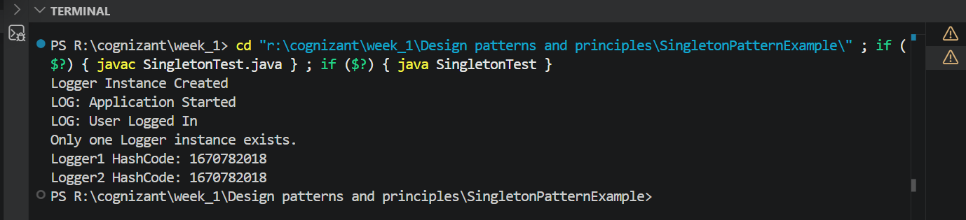
OUTPUT:
Exercise 2: Implementing the Factory Method Pattern
OUTPUT: 